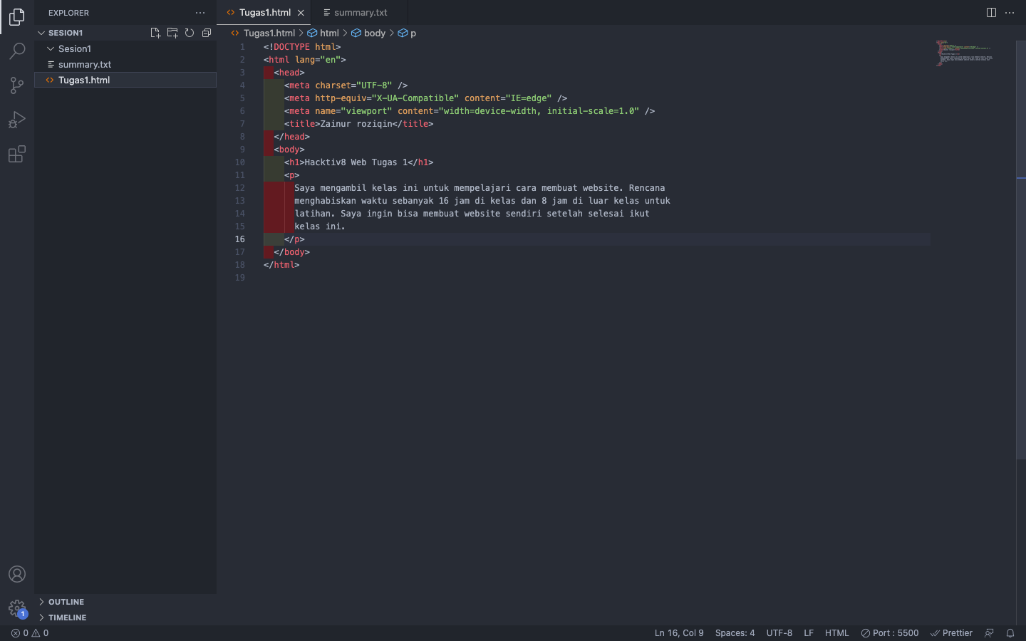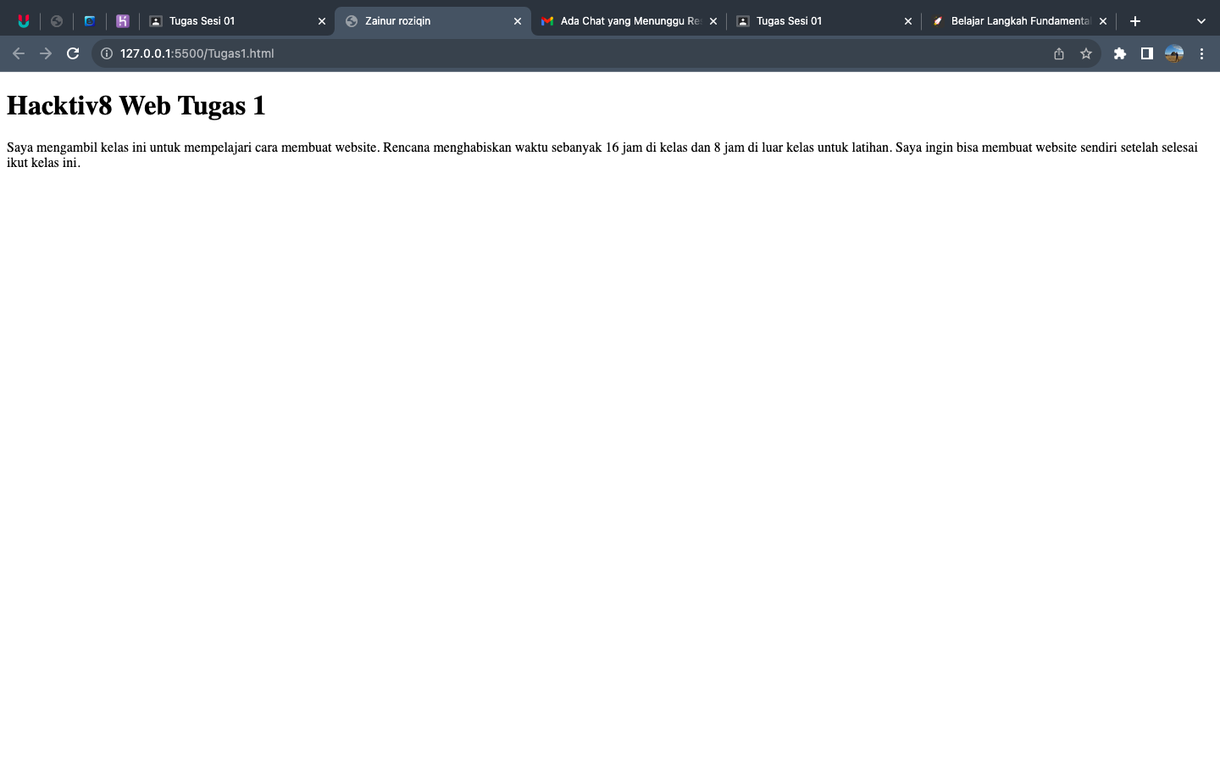Link live server vs code : <http://127.0.0.1:5500/Tugas1.html>